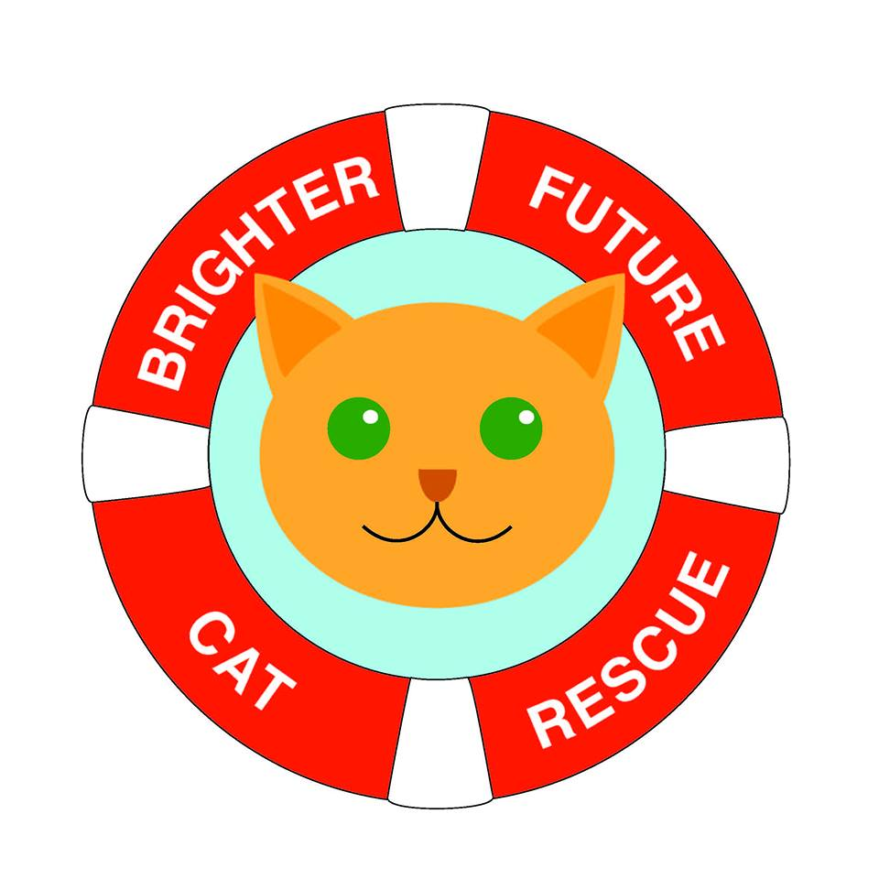
Pre-Adoption Form

Name *
Enter your full name

Email *
Enter your email

Phone *
Enter your phone number

Address *

Drivers Licence Number and Expiry *

Are you a permanent Australian resident? *
Yes
No

Pet Information

Do you already have an animal in mind? Y/N *
If no, what are you looking for? Eg; young cat or senior

Do you know his or her name?Y/N *
If yes, what is it?

Why are you interested in this particular animal, and why does it suit you? *

What characteristics do you like in a cat/dog? *

What characteristics DONT you like in a cat/dog? *

Lifestyle

How many adults live in the household? *
How many children live in the house? *

What is the occupation of the main income earner? *

Who will be responsible for the cat? *

Do you have any pets? Y/N *
If yes, please provide species, breed, sex and age.

Are your current pets desexed/vaccinated/microchipped/registered? *

Do they get along with other animals? *

Does everyone in the house agree about adopting a new pet? Y/N *

Is anyone in the house allergic to animals? Y/N *

How much do you expect to spend on cat food a week? *

How much do you expect to spend on vet care a year? *

Will you be taking out pet insurance? Y/N *

Final Questions

Would you be willing to send us occasional updates and photos of your new furkid? Y/N *

Have you ever been refused an animal you were hoping to adopt? Y/N *
If yes, please provide details.

Please provide first reference details *
Name, Email, Contact Number, Relationship

Please provide second reference details *
Name, Email, Contact Number, Relationship

Any questions you may have for the rescue

By submitting this form, you agree that ALL the information you have provided is correct. You understand that providing false information, or failing to comply with the requirements of this application can lead to the refusal of this adoption. You agree to allow one of our representatives to contact the referees you have provided. We reserve the right to refuse any applicant. *
Agree
Disagree

